EE564 PROJECT #2

MOTOR WINDING DESIGN AND ANALYSIS

CİHAN AYDAR

2043677

TABLE OF CONTENTS

1. INTRODUCTION 3

2. WINDING DESIGN 3

3. MOTOR PARAMETER ESTIMATION 5

4. DETAILED ANALYSIS AND VERIFICATION 6

4.1 INPUTS 6

4.2 OUTPUTS 10

5. CONCLUSION 23

6. REFERENCES 24

LIST OF TABLES

Table 1 Winding Design Parameters 4

Table 2 Winding Design Calculations 4

Table 3 Winding Diagram 5

Table 4 **Hata! Yer işareti tanımlanmamış.**

LIST OF FIGURES

Figure 1 MMF Waveform 5

Figure 2 Stator Inputs 6

Figure 3 Stator Geometry 7

Figure 4 Stator Winding 7

Figure 5 Stator Insulation 7

Figure 6 B-H Characteristics 8

Figure 7 Rotor Structure 8

Figure 8 Rotor Geometry 9

Figure 9 Input Data 9

Figure 11 Locked Rotor Operation 10

Figure 12 Material Consumption 11

Figure 13 No Load Operation 12

Figure 14 Rated Electric Data 12

Figure 15 Rated Magnetic Data 13

Figure 16 Rated Parameters 14

Figure 17 Rated Performance 14

Figure 18 Stator Slot Geometry 15

Figure 19 Stator Winding 16

Figure 20 Phase Current vs Output Power 16

Figure 21 Phase Current vs Speed 17

Figure 22 Power Factor vs Output Power 17

Figure 23 Power Factor vs Speed 18

Figure 24 Efficiency vs Output Power 19

Figure 25 Efficiency vs Speed 19

Figure 26 Torque vs Speed 20

Figure 27 Induced Voltages vs Time 20

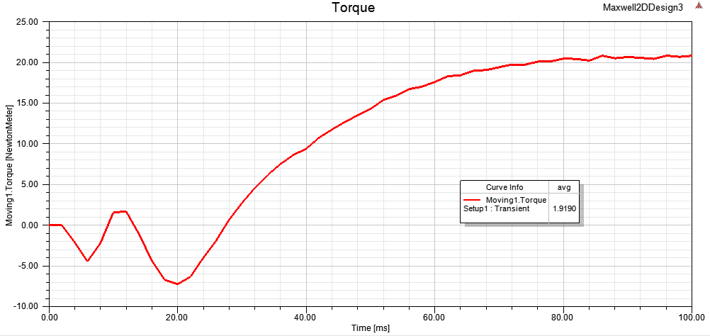Figure 28 Torque vs Time 21

Figure 29 Power vs Time 21

Figure 30 Input Phase Currents 22

Figure 31 Flux Lines 22

Figure 32 Magnitude of Magnetic Flux Density 23

Figure 33 Magnetic Flux Density Vector 23

# 1. INTRODUCTION

The main purposes of project are to design three phase induction motor and then verify it in a FEA program.

# 2. WINDING DESIGN

Firstly, lamination 1 is chosen for induction motor design. All calculation methods can be seen in ‘Winding Design’ excel file.

|  |  |  |  |  |  |
| --- | --- | --- | --- | --- | --- |
| **Number of Poles** | 4 |  |  |  |  |
| **Type of Winding** | Integral, Double Layer, Distributed Winding | 3. H | 5. H | 7. H | 9. H |
| **Winding Factors** | 0,9598 | 0,66667 | 0,21757 | -0,1774 | -0,3333 |
| **Number of Turns** | 180 |  |  |  |  |
| **Wire Size** | 14AWG | < | 2,177 | (mm^2) |  |
| **Fill Factor** | 0,7 |  |  |  |  |
| **Winding Connection** | wye |  |  |  |  |
| **Voltage Rating (V)** | 380 |  |  |  |  |
| **Current Rating (A)** | 4,6 |  |  |  |  |
| **Output Power Rating (W)** | 3000 |  |  |  |  |
| **Frequency** | 50 |  |  |  |  |
| **Input Power Rating (W)** | 3308,15 |  |  |  |  |

Table 1 Winding Design Parameters

|  |  |  |
| --- | --- | --- |
| **Number of StatorSlots** | 36 |  |
| **Slots per Pole** | 9 |  |
| **Slot per Pole per Phase** | 3 |  |
| **Slot Angle (degree)** | 20 | 0,34907 |
| **Conductors per Slot** | 30 |  |
| **Nphase** | 180 |  |

Table 2 Winding Design Calculations

|  |  |  |  |  |  |  |  |  |
| --- | --- | --- | --- | --- | --- | --- | --- | --- |
| **A** | | | **C-** | | | **B** | | |
| a1 | a2 | a3 | c10- | c11- | c12- | b1 | b2 | b3 |
| a10 | a11 | a12 | c7- | c8- | c9- | b10 | b11 | b12 |

|  |  |  |  |  |  |  |  |  |
| --- | --- | --- | --- | --- | --- | --- | --- | --- |
| **A-** | | | **C** | | | **B-** | | |
| a4- | a5- | a6- | c1 | c2 | c3 | b4- | b5- | b6- |
| a1- | a2- | a3- | c10 | c11 | c12 | b1- | b2- | b3- |

|  |  |  |  |  |  |  |  |  |
| --- | --- | --- | --- | --- | --- | --- | --- | --- |
| **A** | | | **C-** | | | **B** | | |
| a7 | a8 | a9 | c4- | c5- | c6- | b7 | b8 | b9 |
| a4 | a5 | a6 | c1- | c2- | c3- | b4 | b5 | b6 |

|  |  |  |  |  |  |  |  |  |
| --- | --- | --- | --- | --- | --- | --- | --- | --- |
| **A-** | | | **C** | | | **B-** | | |
| a10- | a11- | a12- | c7 | c8 | c9 | b10- | b11- | b12- |
| a7- | a8- | a9- | c4 | c5 | c6 | b7- | b8- | b9- |

Table 3 Winding Diagram

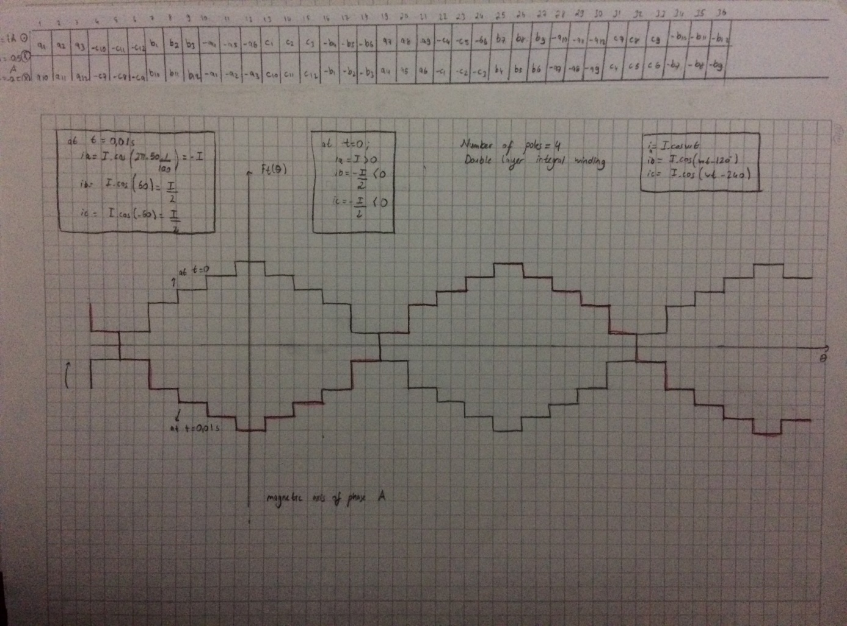

Figure 1 MMF Waveform

# 3. MOTOR PARAMETER ESTIMATION

|  |  |  |  |
| --- | --- | --- | --- |
| **Flux per Pole (Wb)** | 0,00572 |  |  |
| **Bavg (T)** | 0,31667 |  |  |
| **Airgap Clearance (m)** | 0,001 |  |  |
| **Torque (N.m)** | 20,4628 |  |  |
| **Speed (rad/s)** | 146,608 | 1400 | rpm |

|  |  |  |  |
| --- | --- | --- | --- |
| **Axial Length (m)** | **Di (m)** | **Do (m)** | **A (mm^2)** |
| 0,2 | 0,115 | 0,17 | 93,3 |

|  |  |  |  |
| --- | --- | --- | --- |
| **Specific Magnetic Loading (T)** | **Flux Density in Teeth (T)** | **Flux Density in Core (T)** | **Specific Electric Loading-q (A/m)** |
| 0,316665866 | 1,5 | 1,5 | 16962,62751 |

|  |  |  |  |  |
| --- | --- | --- | --- | --- |
| **Full-Load Efficiency** | **Full-Load Power Factor** | **ns (rps)** | **Output Coefficient** | **D^2.L(m^3)** |
| 0,90685043 | 0,8 | 25 | 41,14255258 | 0,002645 |

|  |  |  |  |
| --- | --- | --- | --- |
| **Pole Pitch (m)** | **l_mt (m)** | **Phase Resistance (ohm)** | **Stator Copper Losses (W)** |
| 0,090320789 | 0,84774 | 3,081200902 | 195,5946332 |
|  |  | (17AWG-1,04mm^2) |  |

|  |  |  |  |
| --- | --- | --- | --- |
| **Phase Inductance (mH)** | **Leakage Inductance (mH)** | **Core Mass (kg)** | **Core Loss (W)** |
| 20,3575204 | - | 35,63587087 | 33,85407732 |

Table 4 Calculation Results

# 4. DETAILED ANALYSIS AND VERIFICATION

## 4.1 INPUTS

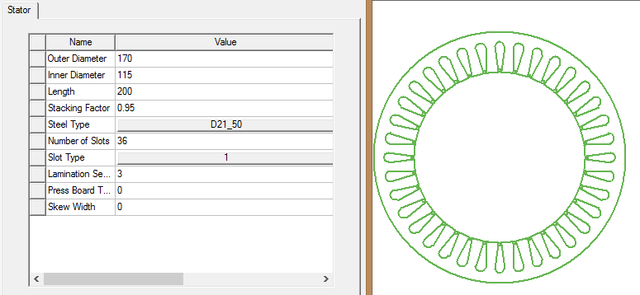

Figure 2 Stator Inputs

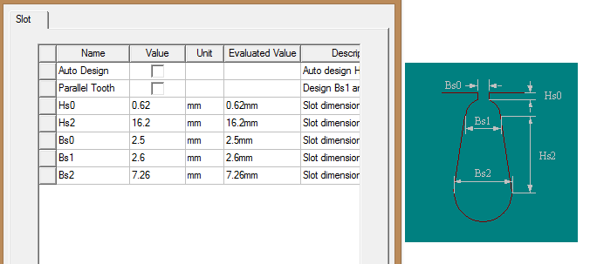

Figure 3 Stator Geometry

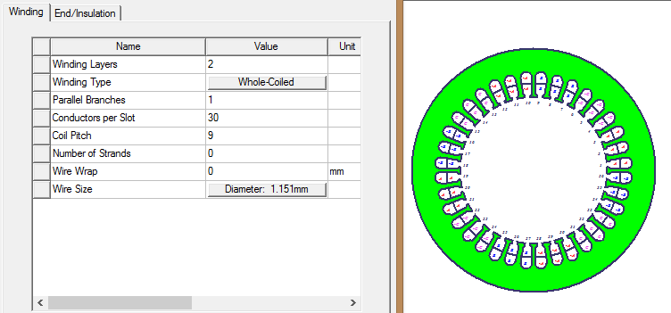

Figure 4 Stator Winding

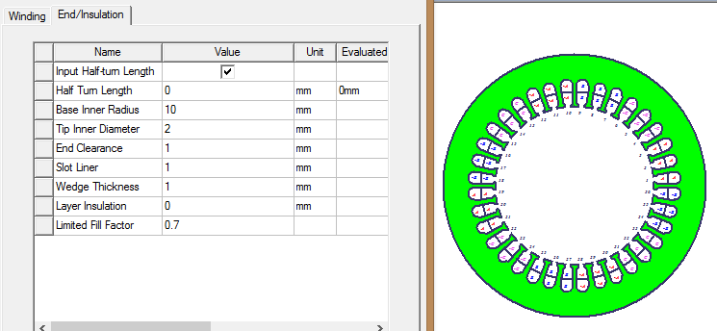

Figure 5 Stator Insulation

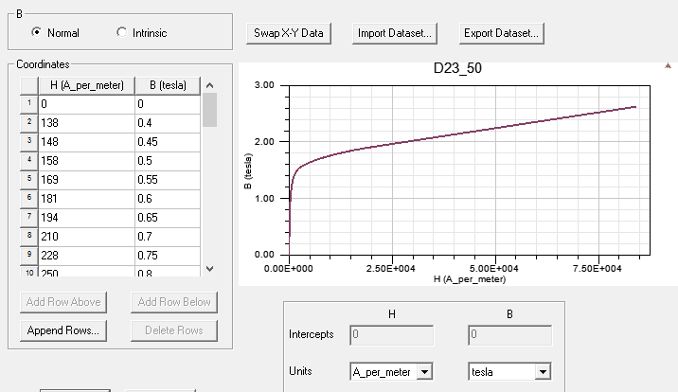

Figure 6 B-H Characteristics

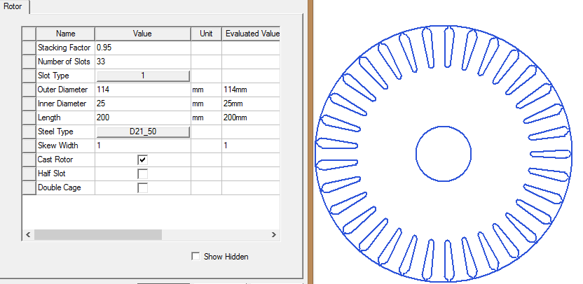

Figure 7 Rotor Structure

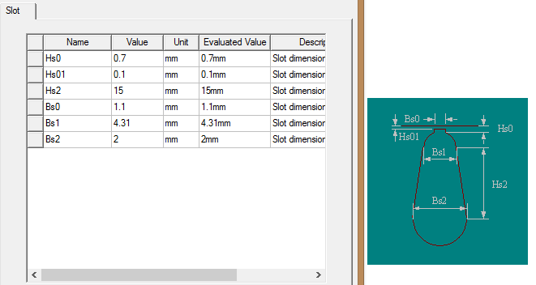

Figure 8 Rotor Geometry

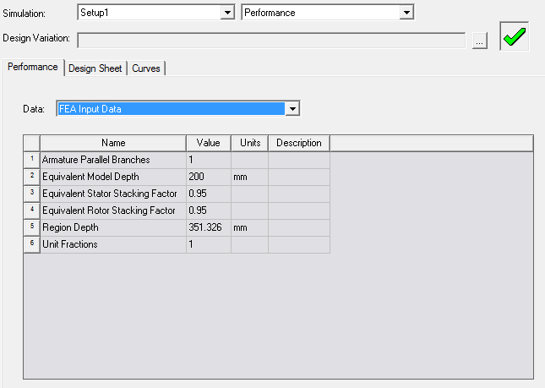

Figure 9 Input Data

## 4.2 OUTPUTS

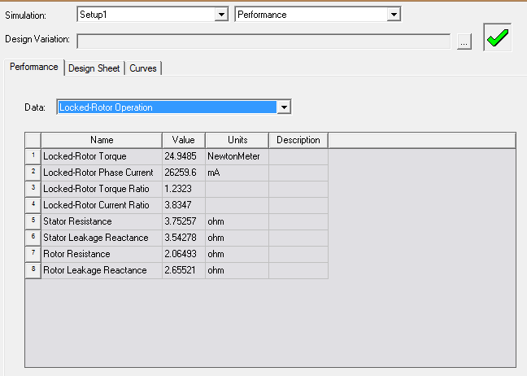

Figure 10 Locked Rotor Operation

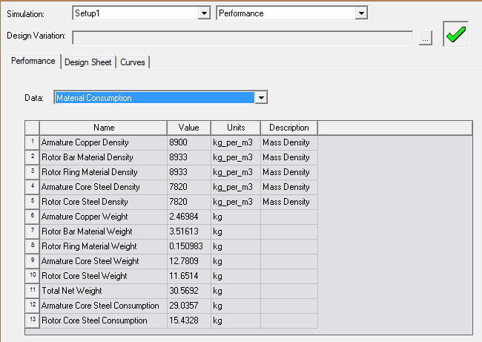

Figure 11 Material Consumption

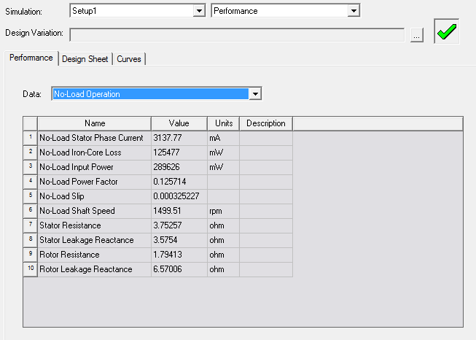

Figure 12 No Load Operation

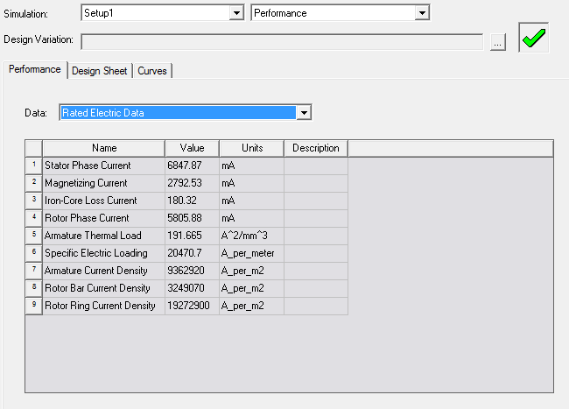

Figure 13 Rated Electric Data

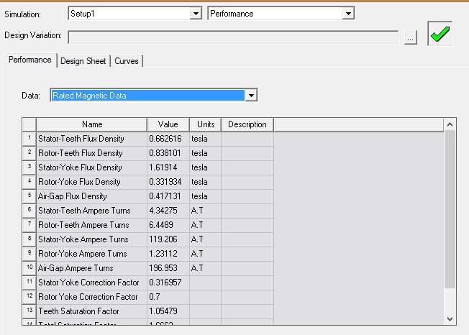

Figure 14 Rated Magnetic Data

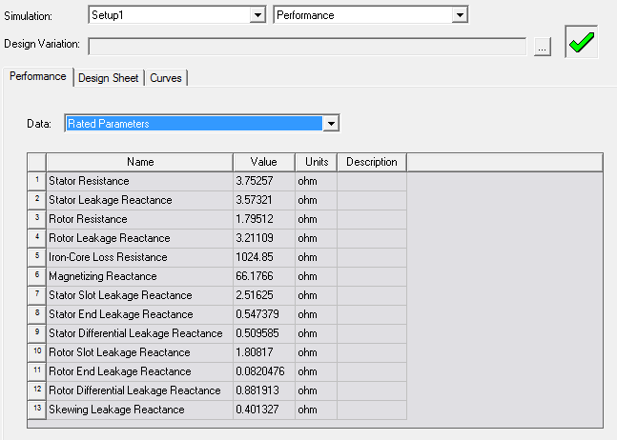

Figure 15 Rated Parameters

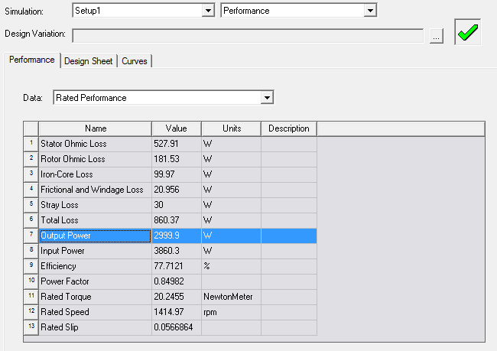

Figure 16 Rated Performance

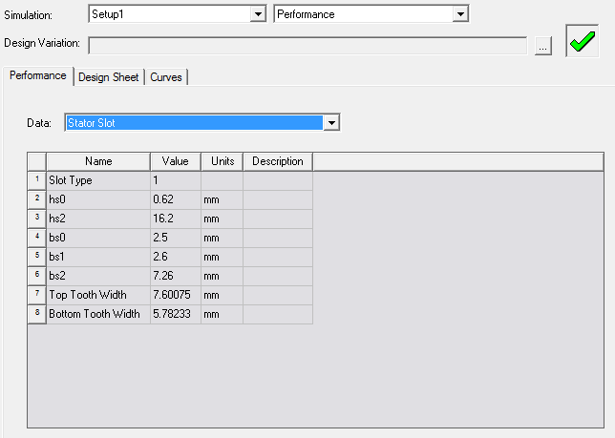

Figure 17 Stator Slot Geometry

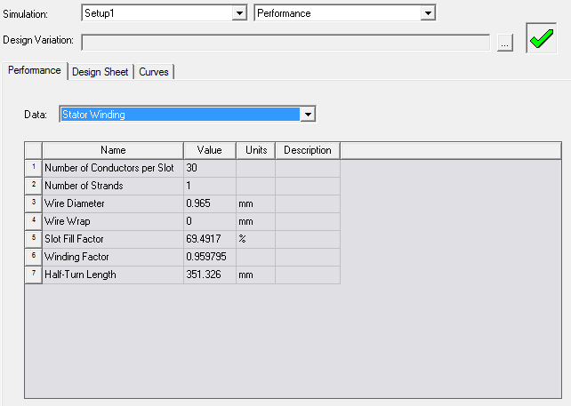

Figure 18 Stator Winding

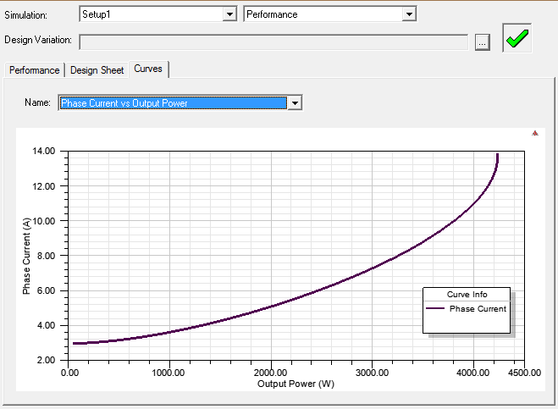

Figure 19 Phase Current vs Output Power

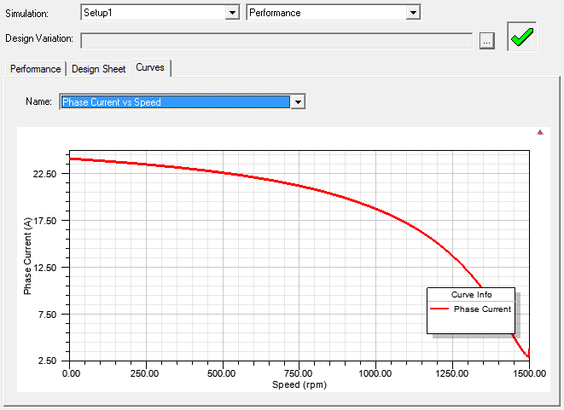

Figure 20 Phase Current vs Speed

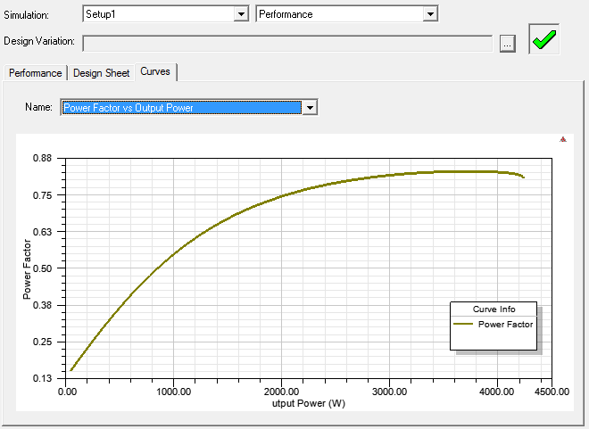

Figure 21 Power Factor vs Output Power

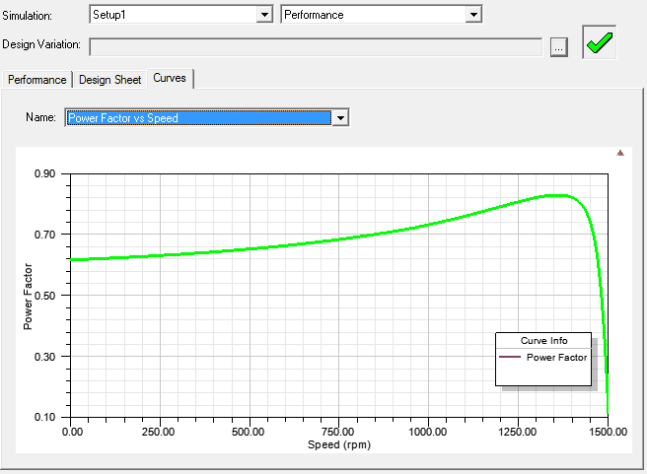

Figure 22 Power Factor vs Speed

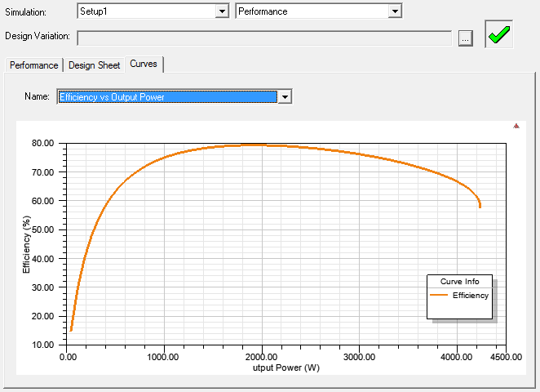

Figure 23 Efficiency vs Output Power

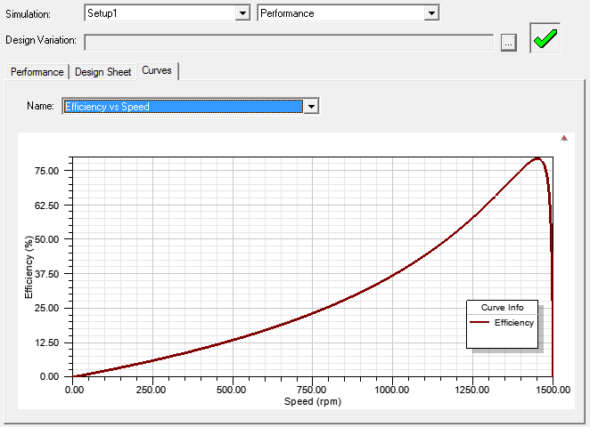

Figure 24 Efficiency vs Speed

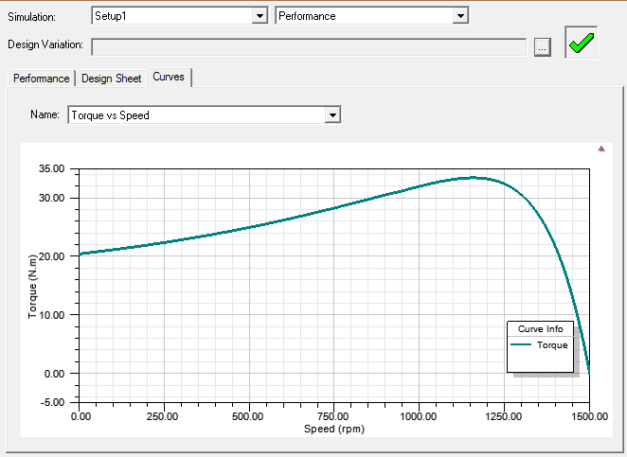

Figure 25 Torque vs Speed

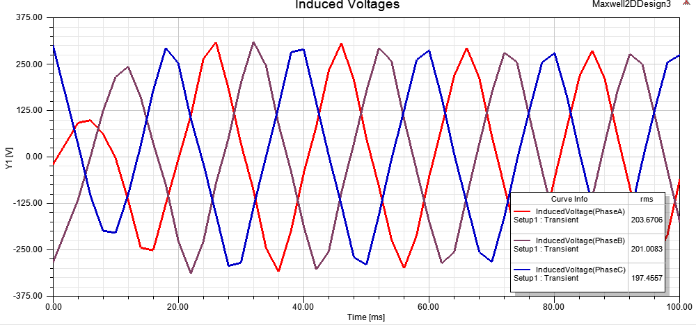

Figure 26 Induced Voltages vs Time

Figure 27 Torque vs Time

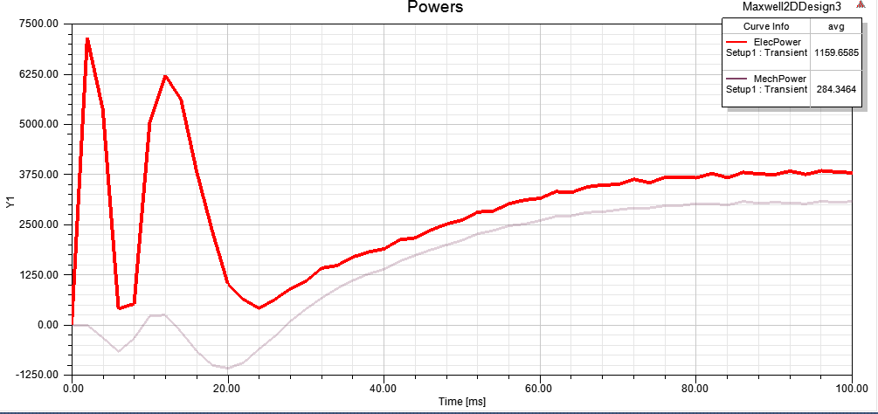

Figure 28 Power vs Time

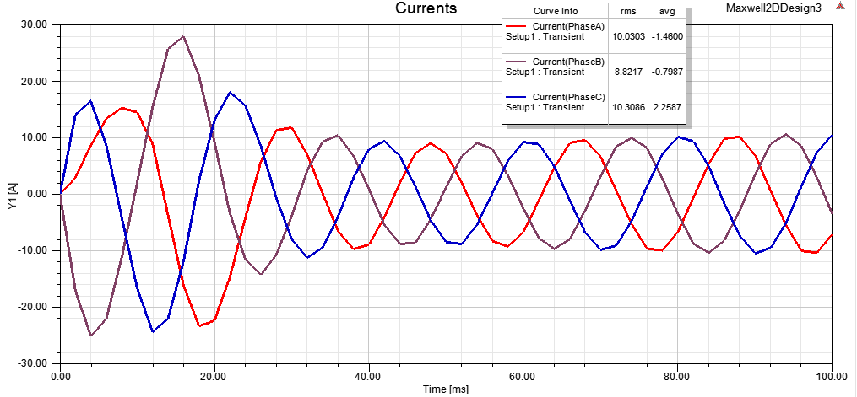

Figure 29 Input Phase Currents

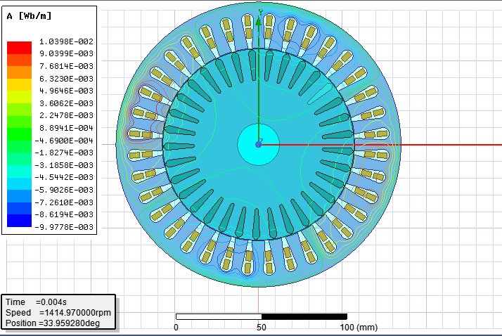

Figure 30 Flux Lines

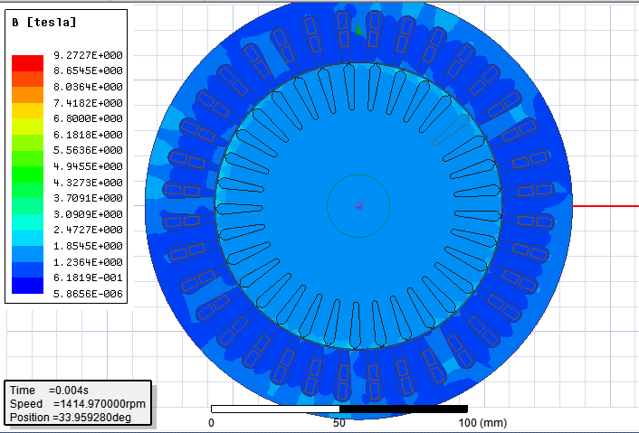

Figure 31 Magnitude of Magnetic Flux Density

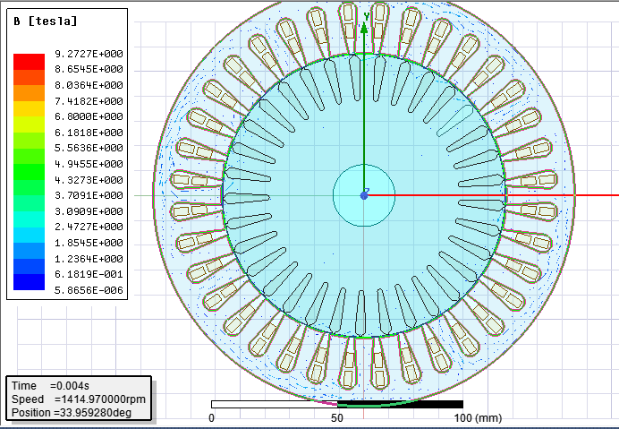

Figure 32 Magnetic Flux Density Vector

# 5. CONCLUSION

There are several significant design goals such as overall system efficiency, weight, cost, size. In order to achieve design optimization goal, the interaction between design parameters must be known well.

Best power factor with maximum efficiency is the main goal of design process. Geometry of the design is already chose. Design steps are based on following algorithm:

1. Calculate magnetic loading to get desired voltage
2. Determine rated torque and speed of induction motor
3. Calculate the approximate core and copper losses at the rated operating conditions by considering friction and windage losses
4. Calculate output coefficient based on geometry and desired output power Q
5. Calculate specific electrical loading

All in all, analytical approach is verified via FEA tool as seen above. All design process such as advantages and disadvantages of different stator designs, choices are referred on ‘Design of Induction Motors’ material [1].

# 6. REFERENCES

[1] Keysan, O. (2018, 03). Design of Induction Motors: Received from http://keysan.me/ee564/